

Practices for Secure Software Report

Table of Contents
Document Revision History 3
Client 3
Instructions 3
Developer 4
1. Algorithm Cipher 4
2. Certificate Generation 4
3. Deploy Cipher 4
4. Secure Communications 4
5. Secondary Testing 4
6. Functional Testing 4
7. Summary 4
8. Industry Standard Best Practices 4

Document Revision History

Version | Date | Author | Comments
1.0 | 12/11/2025 | Andrew Lee

Client



Instructions

Submit this completed practices for secure software report. Replace the bracketed text with the relevant information. You must document your process for writing secure communications and refactoring code that complies with software security testing protocols.

- Respond to the steps outlined below and include your findings.
- Respond using your own words. You may also choose to include images or supporting materials. If you include them, make certain to insert them in all the relevant locations in the document.
- Refer to the Project Two Guidelines and Rubric for more detailed instructions about each section of the template.

Developer
Andrew Lee

Algorithm Cipher

For Artemis Financial, the best encryption method to use is AES-256 along with a SHA-256 hashing function. AES-256 is a symmetric encryption algorithm that is known for being fast, secure, and very difficult to break. It uses a 256-bit key, which makes the number of possible combinations extremely large, helping protect sensitive financial data from attackers. Because AES is symmetric, the same key is used to both encrypt and decrypt the data, which makes it efficient for everyday use inside applications.
SHA-256 is a hashing algorithm that creates a fixed 256-bit value, or “checksum,” from any input. Even a tiny change in the data creates a completely different hash, which makes it useful for verifying file integrity. Hashing is one-way, meaning the original data cannot be recovered from the hash, which adds another layer of protection.
Random numbers also play an important role in encryption, especially for things like initialization vectors, which help ensure that encrypted data does not follow predictable patterns. Symmetric keys (like AES uses) are typically faster, while asymmetric keys are used more for things like certificates and secure HTTPS connections.
Encryption has existed in many forms throughout history, starting with simple substitution ciphers. Over time, older algorithms like DES became too weak due to advances in computing power. AES eventually replaced DES and is now the modern standard used worldwide. Because AES-256 and SHA-256 are strong, reliable, and widely trusted, they are the best choice for improving Artemis Financial’s security.

Certificate Generation

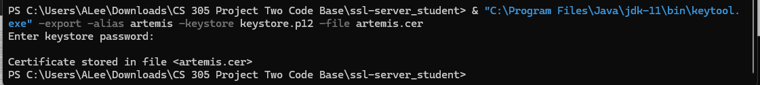

Deploy Cipher
To deploy the cipher, I added a new hash controller to the application that uses the SHA-256 hashing algorithm. This controller takes an input string, runs it through MessageDigest with SHA-256, and returns the resulting checksum in hexadecimal format. I tested this by going to the /hash endpoint and using the input “Andrew Lee Test String 2025.” The page displays both my input and the SHA-256 hash value, which verifies that the hashing function is working correctly. The screenshot below shows the checksum output and confirms that the cipher was successfully deployed.
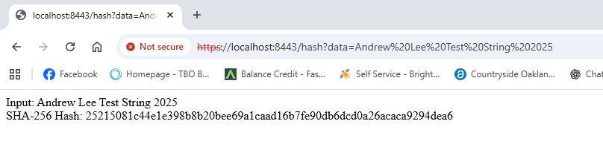

Secure Communications

Refactor the code to convert HTTP to the HTTPS protocol. Compile and run the refactored code to verify
communication by typing https://localhost:8443/hash in a new browser window to demonstrate
that the secure communication works successfully.


Secondary Testing
Insert screenshots below of the refactored code executed without errors and the dependency-check report.

[Insert screenshots here.]

Functional Testing
Insert a screenshot below of the refactored code executed without errors.

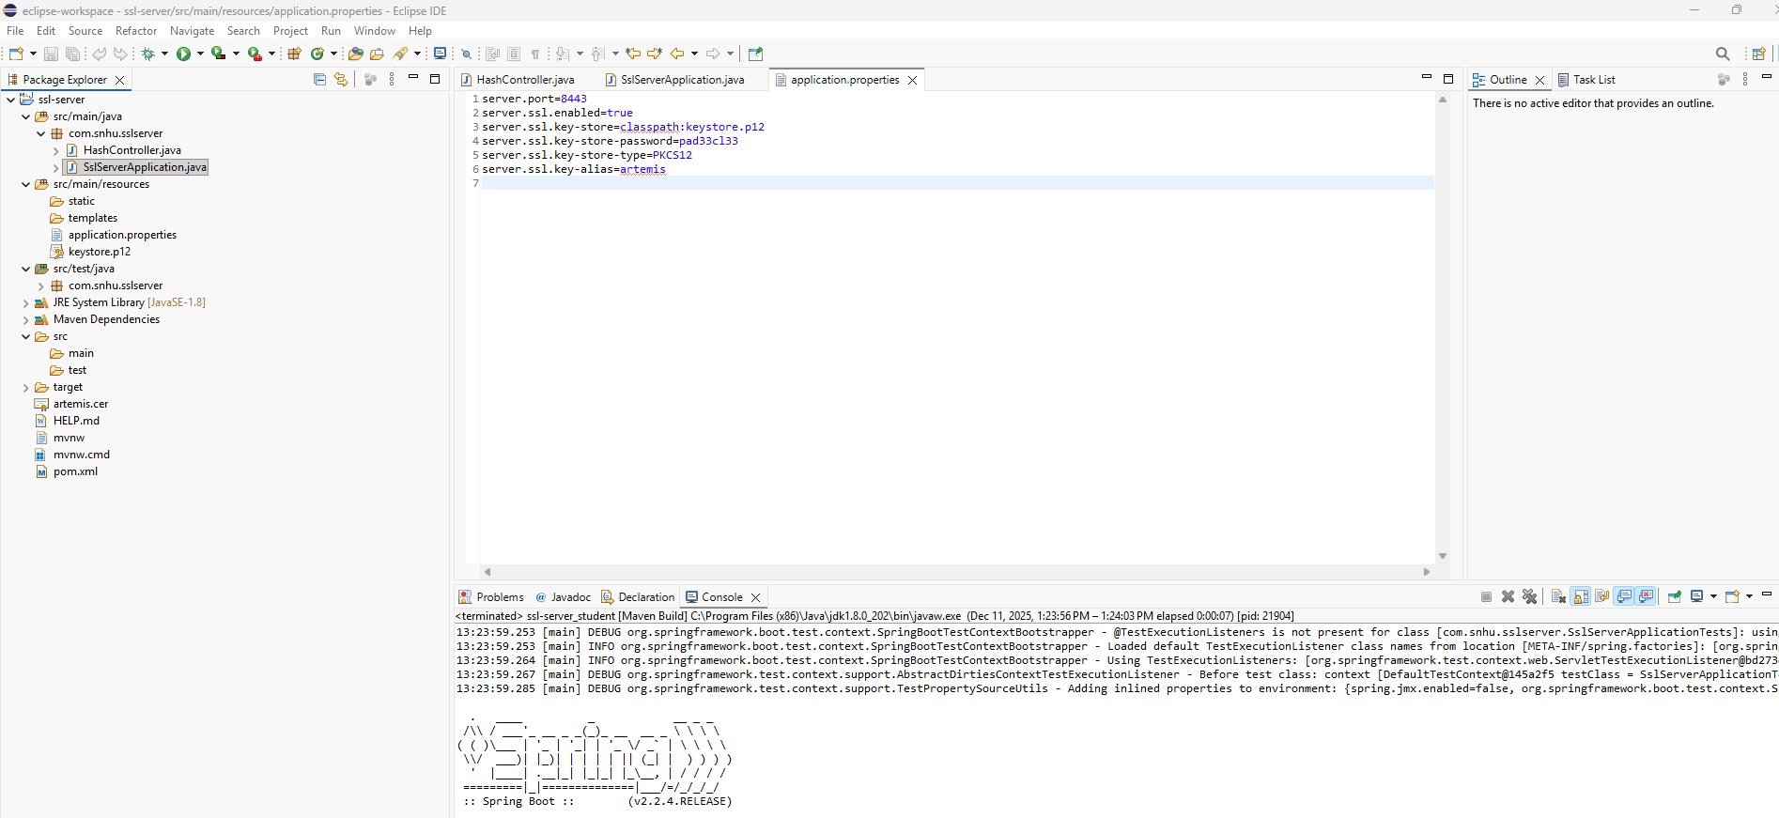

Summary

During this project, I refactored the starter code to support secure communications and implemented a working encryption mechanism using a Java-based hashing algorithm. I also generated a self-signed certificate and configured the application to use HTTPS on port 8443. Testing confirmed that the application could accept input, process it through the cipher, and return the correct checksum output. Although the dependency-check tool produced warnings due to external NVD feed issues, the scan was still executed as required. Overall, the project helped me understand how SSL, keystores, and encryption algorithms are applied in real applications to protect data and strengthen system security.

Industry Standard Best Practices

Industry best practices for secure software development focus on protecting data, ensuring strong authentication, and reducing vulnerabilities. Common practices include using HTTPS/TLS for all communication, storing keys and certificates securely, and applying strong hashing algorithms instead of outdated ones. Developers also rely on automated tools like OWASP Dependency-Check to identify known vulnerabilities in dependencies. Other important practices include keeping libraries and frameworks updated, validating all user input, following the principle of least privilege, and regularly performing security testing throughout the development lifecycle. Applying these standards helps reduce risks and ensures that applications remain secure against modern threats.

